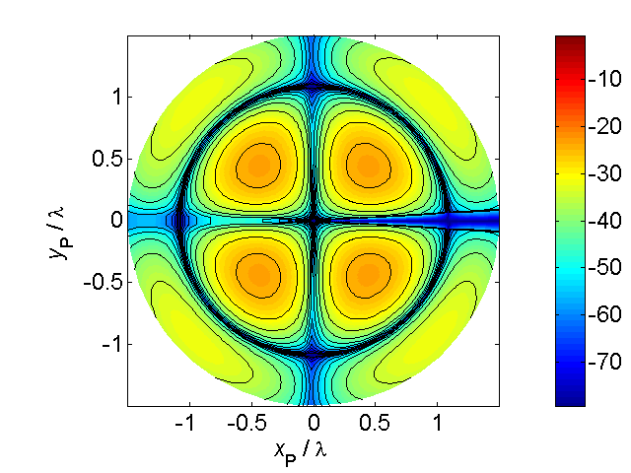[**VISUAL PHYSICS ONLINE**](http://www.physics.usyd.edu.au/teach_res/hsp/sp/spHome.htm)

**QUANTUM MECHANICS;**

**Schrodinger and Heisenberg**

**Quantum Mechanics** or **Wave Mechanics** is the best mathematical theory used today to describe and predict the behaviour of particles and waves. Understanding and applying Quantum Mechanics is crucial in the development of most modern technologies including lasers, semiconductor devices used in mobile phones, display devices, medical imaging machines, etc, etc.

For electrons and other particles in atomic and nuclear systems, the Newtonian laws of motion no longer apply and one must use Quantum Mechanics. When a particle is bound such as an electron in an atom, the electron is described by a wave and the concept of particle and trajectory of the particle have no meaning.

The laws of Quantum Mechanics were developed in the short period from 1924-1928. People such as Planck, Einstein, de Broglie, Schrodinger, Heisenberg and Pauli all made significant contributions to the development of this “strange theory” which has startling consequences.

Among physicists, it was a period of great excitement, many of the unexplained facts of physics and chemistry know for more than 50 years seemed suddenly to tumble into place.

If electrons do have a wave nature as suggested by de Broglie, it should be possible to represent them by a suitable mathematical function known as a wavefunction Ψ. In water waves, the physical quantity that varies periodically is the height of the water surface (Ψ ∝ *h*). In sound waves, the variable quantity is the pressure in the medium the waves travel through (Ψ ∝ *p*). In light waves, the variable quantities are the electric and magnetic fields (Ψ ∝ *E* or *B*).

*What is it that varies in the case of matter waves?*

The quantity whose variation constitutes the matter wave of a moving object is known as its **wavefunction Ψ** (psi). Surprisingly, the wavefunction Ψ for a matter wave can’t be related to anything physical, it is only a mathematical concept. However, when mathematical operations are carried out on the wavefunction, predictions can be made for the probability of locating an electron and the total energy of the electron.

The value of the square of the wavefunction  is proportional to probability of finding the particle at a certain time and location. For this reason, the quantity  is called the **probability density function** of the particle. A large value of signifies a large probability of finding the particle at a specified time and location and a low value of implies that it is unlikely to find the particle at the specified time and location. Thus, matter waves may be regarded as waves of probability.

A group or packet of matter waves is associated with every moving object. The packet travels with the same velocity as the object does. The waves in the packet have the average de Broglie wavelength. Even though we can’t visualise what is meant by Ψ and so can’t form a mental image of matter waves, the amazing agreement between measurements and the predictions of Quantum Mechanics means that we have to accept the bizarre concepts of Quantum Mechanics.

In ordinary mechanics, a particle can have any energy including zero. But when we describe the particle behaviour using Quantum Mechanics, we find that the particle’s energy is always greater than zero and for a bound particle (e.g. electron in an atom) the particle can only have certain discrete values for its energy. Quantum (wave) Mechanics naturally leads to the concept of **quantisation**.

Quantum Mechanics tells us that we can now longer predict exactly where a particle like an electron will travel. For example, when electrons are reflected off a metal crystal a diffraction pattern is formed. We only know the probability of where the electron would be observed. We can’t determine the trajectory for the electron. This idea leads to the Uncertainty Principle which is an important consequence of Quantum Mechanics.

**Heisenberg Uncertainty Principle**

When we consider the problem of actually measuring the position of a particle, we realise that it presents difficulties. First, there is the difficulty of designing instruments fine enough to measure small structures, such atoms and molecules. There is also the problem of the instrument disturbing the system (as when a large thermometer is used to measure the temperature of a small quantity of liquid). We might expect to correct for such effects, but deeper consideration shows that this is not such a simple matter. For example, to locate the position of an electron in one of its orbits we must look at it - that is, receive a signal from it. If it emits the signal itself, it must change orbit. If it reflects a photon, then the photon must collide with it, thus changing its position. No experiment that we can devise will enable us to look at the electron without some change occurring to the electron.

In 1927, Werner **Heisenberg** proposed and demonstrated that we can’t know in principle the absolutely precise values that will completely describe a physical system. His uncertainty principle states that attempts to know simultaneously the complementary facts required to describe a system are doomed.

Consider a particle travelling along the x-axis and at time *t* measurements (magnitudes and uncertainties) are made of its position  and momentum. Then, one mathematical version of the Heisenberg Uncertainty Principle is

(1) 

Equation 1 implies that it is impossible to know the exact values of a particles position and momentum simultaneously. The better we know the location of the particle, then the greater must be the uncertainty in the particle’s momentum.

Planck’s constant is very small (*h* = 6.63x10-34 J.s), so for macroscopic objects the uncertainty principle is of no consequence, but that is not the case for atomic sized systems.

According to the uncertainty principle, we can never obtain precise knowledge of a physical system, regardless of improvements in experimental techniques. We can only obtain probable values, and this is a characteristic of nature. This principle provided a tremendous support for the methods of Wave Mechanics. It showed that there was an uncertainty inherent in nature, and this was precisely what Wave Mechanics predicted. The theory has been immensely successful in providing correct solutions to many scientific problems, and is one of the corner stones of contemporary physics.

There are limits to what we can know. The premise: “ *if we know the present exactly, we can calculate the future*" is wrong.

**Quantum Mechanics Concepts**

In classical physics, given an initial position and initial velocity for a particle then if one knew the forces acting on the particle, Newton’s second law could be solved to accurately predict the position and velocity in the future. This concept is not true, especially in atomic systems. Quantum Mechanics tells us that we can only talk about the probability of certain events occurring. In Quantum Mechanics, the starting point is to set up a wave equation describing a particle in some system. This equation is known as the **Schrodinger Equation**. Solving this equation gives a wavefunction which gives complete knowledge of the particle in the system.

For electrons in atoms, four numbers are necessary to specify the wavefunction which is a solution to the wave equation for that system. These four numbers describe the **state** of the electron. These four numbers are a natural consequence of the wave nature of matter. These **four quantum numbers** are

* Principal quantum number *n n* = 1, 2, 3, …
* Angular momentum number *l l =* 0, 1, 2, … , (*n* - 1)
* Magnetic quantum number *ml*

*ml =* -*l*, -l+1, … , 0, 1, 2, … , *l*

* Spin quantum number *ms ms* = -1/2, +1/2

The principal quantum *n f*ulfils the same role as the quantum number *n* in the Bohr theory of the atom, i.e. the energy levels obtained are given by the value of *n.* The quantum number *l* determines the angular momentum of the electron, whereas *ml* determines the component of the angular momentum along a prescribed direction, for example, the alignment in an external magnetic field. The spin quantum number *ms* arises from the spin angular momentum of the electron.

**In one atom, no two electrons can have the same set of four quantum numbers.**

This is known as the **Pauli Exclusion Principle**. This principle is the key to understanding the behaviour of the elements in the periodic table.

The principle quantum number *n* basically determines the shell for the location of the electron and its energy.

The angular quantum number *l d*etermines the subshell for the location of the electron. The value of *l i*s often replaced by a letter to specify the type of state for the electron

*l:* 0  s, 1  p, 2  d, 3  f, 4  g …

Using the restrictions on the values of the four quantum numbers, and the Pauli Exclusion Principle it is possible to give the electronic configuration of all the elements in the periodic table for atoms in the ground state where the lowest energy levels are filled first.

The total number of states for *n* is equal to 2*n*2

*n* = 1st shell  2 electrons

*n* = 2nd shell  8 electrons

n= 3rd shell  18 electrons

Number of electrons in subshells

s-state  2 p-state  6 d-state  10 f-state  14

s subshell  2 electrons

p subshell  6 electrons

d subshell  10 electrons

The electronic configuration is often written in a condensed format, for example,

Carbon has six electron 1s2 2s2 2p2

The electronic configuration of the 1st twenty elements of the periodic table;

1 H 1s1

2 He 1s1

3 Li 1s2 2s1

4 Be 1s2 2s2

5 B 1s2 2s22p1

6 C 1s2 2s22p2

7 N 1s2 2s22p3

8 O 1s2 2s22p4

9 F 1s2 2s22p5

10 Ne 1s2 2s22p6

11 Na 1s2 2s22p6 3s1

12 Mg 1s2 2s22p6 3s2

13 Al 1s2 2s22p6 3s23p1

14 Si 1s2 2s22p6 3s23p2

15 P 1s2 2s22p6 3s23p3

16 S 1s2 2s22p6 3s23p4

17 Cl 1s2 2s22p6 3s23p5

18 A 1s2 2s22p6 3s23p6

19 K 1s2 2s22p6 3s23p6 4s1

20 Ca 1s2 2s22p6 3s23p6 4s2

Lower energy states can be achieved when the shells and subshells are full. Hence, from the electronic configuration we can easily predict the chemical behaviour of each element and the type of chemical bond it is most likely to form.

The least reactive elements (noble gases) have complete shells and subshells

2 He 1s1

10 Ne 1s2 2s22p6

18 A 1s2 2s22p6 3s23p6

The active metals can easily lose an electron to form positive ions

11 Na 1s2 2s22p6 3s**1**

19 K 1s2 2s22p6 3s23p6 4s**1**

Active non-metals can easily gain an electron to form negative ions

9 F 1s2 2s22p**5**

17 Cl 1s2 2s22p6 3s23p**5**

Sodium and chlorine will join together in an ionic bond as the sodium atom can easily lose an electron and the chlorine atom can easily gain this electron to give complete shells / subshells.

Na – e**-**  Na**+** Cl + e**-**  Cl**-** Na**+**Cl**-**

**Hydrogen atom**

The Rutherford-Bohr model of the atom described the electron orbiting around the nucleus in circular orbits. This is a planetary model like the planets orbiting the Sun.

However, in terms of Quantum Mechanics the electron has to be regarded as a wave so that experimental observations agree with theoretical predictions. The Schrodinger Wave Equation for a hydrogen atom can be easily solved to give the wavefunction Ψ describing the electron and the state of the electron given by the four quantum numbers (*n*, *l*, *ml*, *ms*). The **ground state** of a hydrogen atom (lowest energy level) has the quantum numbers (1,0,0,±1/2). Higher energy states are called **excited states**.

The following diagrams show the electron densities for an electron in the ground state and a number of excited sates. The dimensions (width and height of displayed image) are given in terms of the Bohr radius *a0* = 5.29x10-11 m and the binding energy *EB,* energy needed to remove the electron (ionization) from the atom are given in electron-volts (eV). The diagrams clearly show the ideas of shells and subshells. s-subshells are spherical while p-subshell have a dumbbell shape. There are regions of high probability of finding the electron and other regions where the probability is zero (the electron will never be found at these locations). The electron density patterns are similar to standing wave patterns (regions of nodes and antinodes). Consider the states with n = 2. Separating regions of high probability are zones of zero probability, hence it is meaningless to think about the electron moving around the nucleus in some type of trajectory. To try and have a three-dimensional view, take the z-axis as pointing to the top of the page and in the plane of the page through the centre of the atom, then rotate each diagram about the z-axis. The higher the principle quantum number *n*, on average the electron is further from the nucleus and hence its binding energy is lower.



Ground state: *n* = 1 *l* = 0 *ml* = 0

(s orbital)

dimensions = 20*a*0 x 20*a*0

*EB* = 13.6 eV



Excited state: *n* = 2 *l* = 0 *ml =* 0

(s orbital)

dimensions = 40*a*0 x 40*a*0

*EB* = 3.4 eV



Excited state: *n* = 2  *l* = 1 *ml* = 0

(p orbital)

dimensions = 40*a*0 x 40*a*0

*EB* = 3.4 eV



Excited state: *n* = 2 *l =* 1 *ml =* ±1

(p orbital)

dimensions = 40*a*0 x 40*a*0

*EB* = 3.4 eV

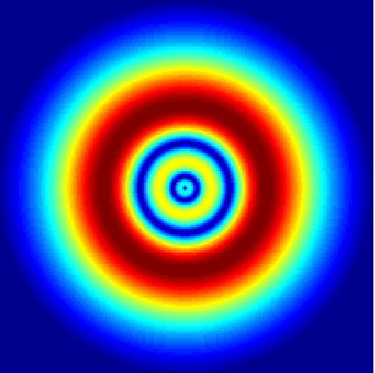

Excited state:

*n* = 3

*l =* 0 *ml =* 0

(s orbital)

Dimensions = 60*a*0 x 60*a*0

*EB* = 1.51 eV



Excited state: *n* = 3 *l =* 1 *ml =* 0

dimensions = 60*a*0 x 60*a*0

*EB* = 1.51 eV



Excited state: *n* = 3 *l* = 2 *ml =* 0

dimensions = 60*a*0 x 60*a*0

*EB* = 1.51 eV



Excited state: n = 4 *l* = 3 *ml =* 1

dimensions = 100*a*0 x 100*a*0

*EB* = 0.85 eV

**People who shaped out modern world – The Giants of the Quantum World**

**Erwin Rudolf Josef Alexander Schrodinger**

German physicist: 12 August 1887 – 4 January 1961.

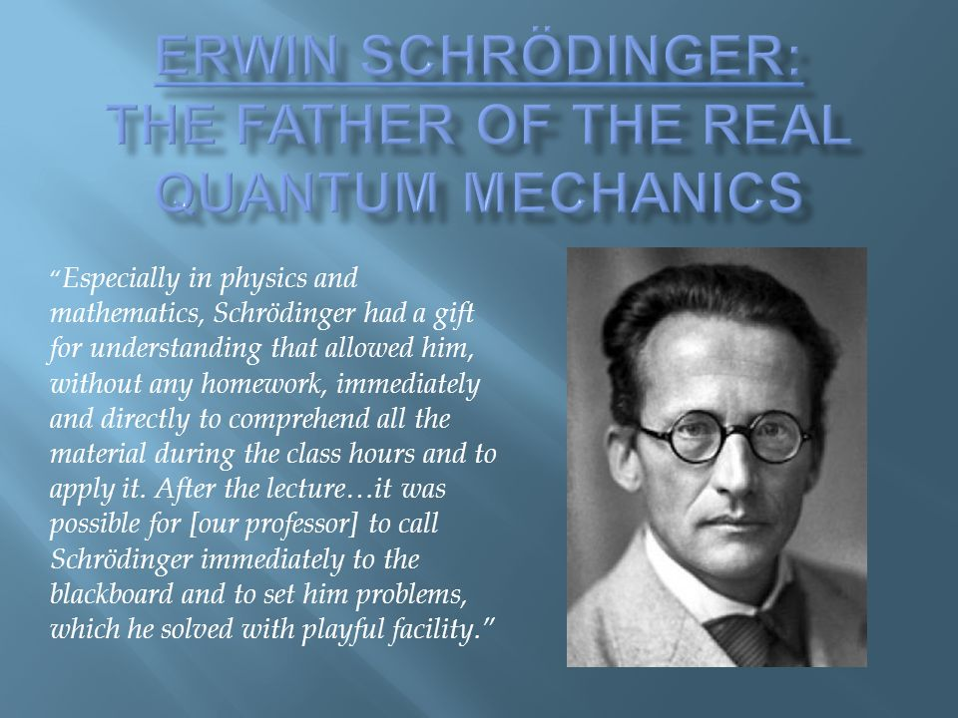

Awarded the Nobel Prize for his development of a number of fundamental results in the field of quantum theory, which formed the basis of wave mechanics. He formulated the wave equation (stationary and time-dependent Schrödinger equation) and revealed the identity of his development of the formalism and matrix mechanics. Schrodinger proposed an original interpretation of the physical meaning of the wave function.

In January 1926, Schrödinger published in Annalen der Physik the paper "Quantisierung als Eigenwertproblem" [Quantization as an Eigenvalue Problem] on wave mechanics and presented what is now known as the Schrodinger equation. In this paper, he gave a "derivation" of the wave equation for time-independent systems and showed that it gave the correct energy eigenvalues for a hydrogen-like atom.

 *This equation explains all of chemistry*

This paper has been universally celebrated as one of the most important achievements of the twentieth century and created a revolution in most areas of quantum mechanics and indeed of all physics and chemistry.

Schrodinger was not entirely comfortable with the implications of quantum theory. Schrodinger wrote about the probability interpretation of quantum mechanics, saying: "I don't like it, and I'm sorry I ever had anything to do with it."

**Werner Karl Heisenberg**

German physicist December 1901 – 1 February 1976

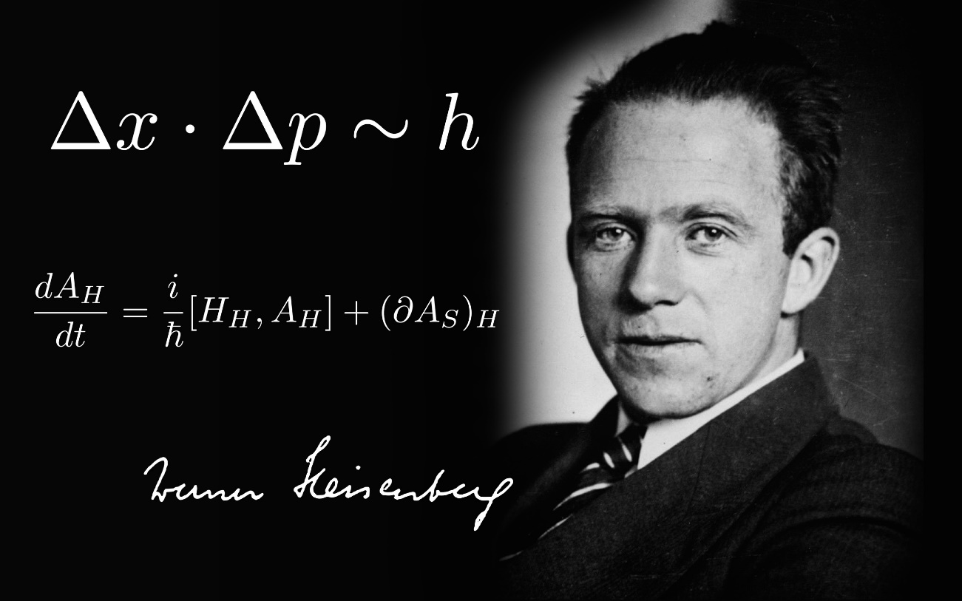

He was a German theoretical physicist and one of the key pioneers of quantum mechanics. He published his work in 1925 in a breakthrough paper. In the subsequent series of papers with Max Born and Pascual Jordan, during the same year, this matrix formulation of quantum mechanics was substantially elaborated. He is known for the Heisenberg uncertainty principle, which he published in 1927. Heisenberg was awarded the Nobel Prize in Physics for 1932 "for the creation of quantum mechanics".

**Wolfgang Ernst Pauli**

Austrian-born Swiss and American theoretical physicist 25 April 1900 – 15 December 1958

He was an and one of the pioneers of quantum physics. In 1945, after having been nominated by Albert Einstein, Pauli received the Nobel Prize in Physics for his "decisive contribution through his discovery of a new law of Nature, the exclusion principle or Pauli principle". The discovery involved spin theory, which is the basis of a theory of the structure of matter. Pauli proposed in 1924 a new quantum degree of freedom (or quantum number) with two possible values, in order to resolve inconsistencies between observed molecular spectra and the developing theory of quantum mechanics. He formulated the Pauli exclusion principle, perhaps his most important work, which stated that no two electrons could exist in the same quantum state, identified by four quantum numbers including his new two-valued degree of freedom. The idea of spin originated with Ralph Kronig. George Uhlenbeck and Samuel Goudsmit one year later identified Pauli's new degree of freedom as electron spin.

In 1926, shortly after Heisenberg published the matrix theory of modern quantum mechanics, Pauli used it to derive the observed spectrum of the hydrogen atom. This result was important in securing credibility for Heisenberg's theory.

[View video on Pauli](https://www.youtube.com/watch?v=3VMa3ZG9wlw)

[A must watch full-length documentary video: QUANTUM THEORY](https://www.youtube.com/watch?v=CBrsWPCp_rs&t=2408s)

[VISUAL PHYSICS ONLINE](http://www.physics.usyd.edu.au/teach_res/hsp/sp/spHome.htm)

If you have any feedback, comments, suggestions or corrections please email:

Ian Cooper School of Physics University of Sydney

ian.cooper@sydney.edu.au